The end effector, at the beginning of the semester, was still in the design phase of the process. A general concept design had been made, shown in Figure #, but little thorough design work had been done yet.

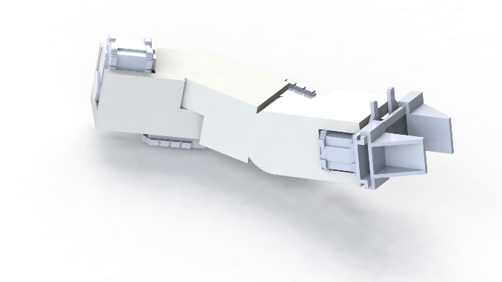

Figure #: A previous conceptual design of the end effector

The end effector started the semester with a simple requirement of only lifting light loads for tasks, such as the soil sample task. However, due to rule changes, the end effector must now complete the payload deployment task as well. This task will require the end effector to be able to lift 5 kilograms, so we needed to adjust our requirements for our servos and bracket strength accordingly. This required our design to be stronger and able to withstand more stress, while at the same time keeping the overall weight and cost low. After several redesigns of the Solidworks assembly model, the end effector has a reasonable stress and displacement threshold, as shown through the stress testing done within Solidworks, and is now in the process of being manufactured by a CNC machine.

Currently, we have in our possession the three servos that will compose the End Effector. These three servos have been selected based on our estimated torque requirements for each rotational movement. The middle servo is slightly different than the other two since it has a larger torque output at 3600 ounces per inch versus the lighter 1200 ounces per inch. Both types of servos are shown below in Figure #.

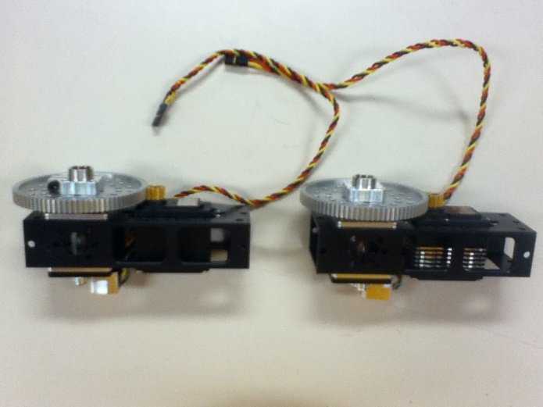

Figure #: The two types of servos used

This is necessary since the middle servo rotates the End Effector in the vertical plane. Due to this rotational plane, the servo has to fight gravity to a larger extent than the other two servos.

Also, we have designed the brackets used to connect the three servos together. The brackets will be made out of 70-75 aluminum and will be crafted in the CNC machines. The brackets have been designed to maximize durability and minimize weight while keeping the rotational axis along a common center. This will allow easier control over the End Effector by minimizing the confusion of multiple axis of rotation. Furthermore, due to the design of the brackets, the potential rotational movement is only limited in the vertical plane. Realistically, the End Effector will only need to rotate 180˚ horizontally and vertically. Due to some of the requirements of the tasks, having 360˚ of freedom of roll for the last servo will allow us to screw in pieces during the Construction task.

Going forward, there are three main objectives left to complete before competition. The first one is the manufacturing of the brackets used to connect all of the servos together. The designs for the brackets are complete so the last step is to take these designs to the CNC machines to be crafted. The second objective is to design and manufacture the part that will act as our gripper. This gripper will go on the end of the End Effector and will be used as a way for MAVRIC to interact with its environment during the competition tasks. Currently, we are looking at different designs used in industry to find one that we can accurately replicate with our own current materials. Thirdly, rigorous testing needs to be done on the End Effector. During and after the testing we will be evaluating the performance of the End Effector as a whole and each of the individual components. This will allow us to decide if each part has been manufactured to our specifications and if they will complete the required tasks at competition. If any of these parts do not meet the goals, we will have to redesign them with the remaining time and resources left to us. A model of the completed end effector is shown below for reference, in Figure #.

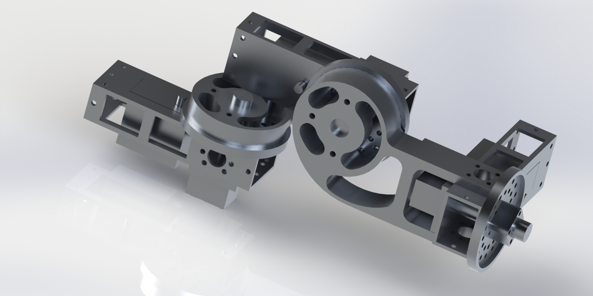

Figure #: Final design of the end effector